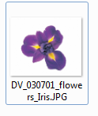

Caption ID of Parent: 114091

Source: Digital Vision

Source ID: 030701

Rights Type: Royalty Free

Credit: © Digital Vision

K12 Credit: Iris. © Digital Vision

RM Assets Embedded: No

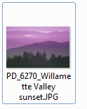

Caption ID of Parent: 102544

Source: Photodisc

Source ID: 6270

Rights Type: Royalty Free

Credit: © Photodisc

K12 Credit: Sunset. © Photodisc

RM Assets Embedded: No

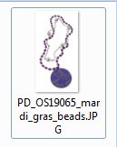

Caption ID of Parent: 110653

Source: Photodisc

Source ID: OS19065

Rights Type: Royalty Free

Credit: © Photodisc

K12 Credit: Mardi Gras beads. © Photodisc

RM Assets Embedded: No

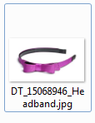

Caption ID of Parent: 927759

Source: Dreamstime

Source ID: 15068946

Rights Type: Royalty Free

Credit: © Carabiner/Dreamstime.com

K12 Credit: Hair band. © Carabiner/Dreamstime.com

RM Assets Embedded: No

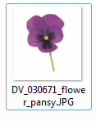

Caption ID of Parent: 114064

Source: Digital Vision

Source ID: 030671

Rights Type: Royalty Free

Credit: © Digital Vision

K12 Credit: Pansy. © Digital Vision

RM Assets Embedded: No

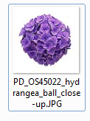

Caption ID of Parent: 111284

Source: Photodisc

Source ID: OS45022

Rights Type: Royalty Free

Credit: © Photodisc

K12 Credit: Hydrangea flower. © Photodisc

RM Assets Embedded: No

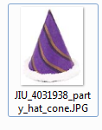

Caption ID of Parent: 116506

Source: Jupiterimages

Source ID: 4031938

Rights Type: Royalty Free

Credit: © Jupiterimages

K12 Credit: Party hat. © Jupiterimages

RM Assets Embedded: No



Caption ID of Parent: 104365

Source: Photodisc

Source ID: OS49040

Rights Type: Royalty Free

Credit: © Photodisc

K12 Credit: Eggplant. © Photodisc

RM Assets Embedded: No



Caption ID of Parent: 1300045

Source: Shutterstock

Source ID: 66169651

Rights Type: Royalty Free

Credit: © Shutterstock.com

K12 Credit: Purple shoes. © Shutterstock.com

RM Assets Embedded: No